Market Analysis of Corporate Wellness Services

Natalie Chiang | Andrew Xia | Allahverdi Suleymanov | Tianyi Li

#### **1. Industry at a glance**

The corporate wellness industry encompasses companies that provide programs to organizations aiming to improve the health of their employees and their families. For this reason, market segments are largely composed of the different types of organizations that employ people: non-profit organizations, small private sector businesses, the public sector, mid-size private sector businesses, and large private sector businesses.

Given the fragmented nature of the industry, less than 23.0% of industry revenue was expected to be accounted for by the top four companies in 2016 (Turk). One such company is ComPsych, providing a holistic approach to corporate wellness that includes behavioural health and work-life balance programs. Another is OptumHealth Inc., whose services include wellness coaching, biometric screenings, and health promotion, among others.

Since these are external companies providing services to organizations, regulation is light. However, accreditation programs do exist: in the US, the Wellness & Health Promotion Accreditation was launched by the National Committee for Quality Assurance 2009, assessing the health plans of wellness services and evaluating how they're implemented.

The supply chain consists of companies that provide the various components of the program. Examples of this include printing services that provide materials to outline the health program, medical device manufacturers that provide equipment used for medical screenings, and software companies that support and enhance wellness services.

With many businesses seeking to lower healthcare costs by adopting wellness programs, the industry is growing.

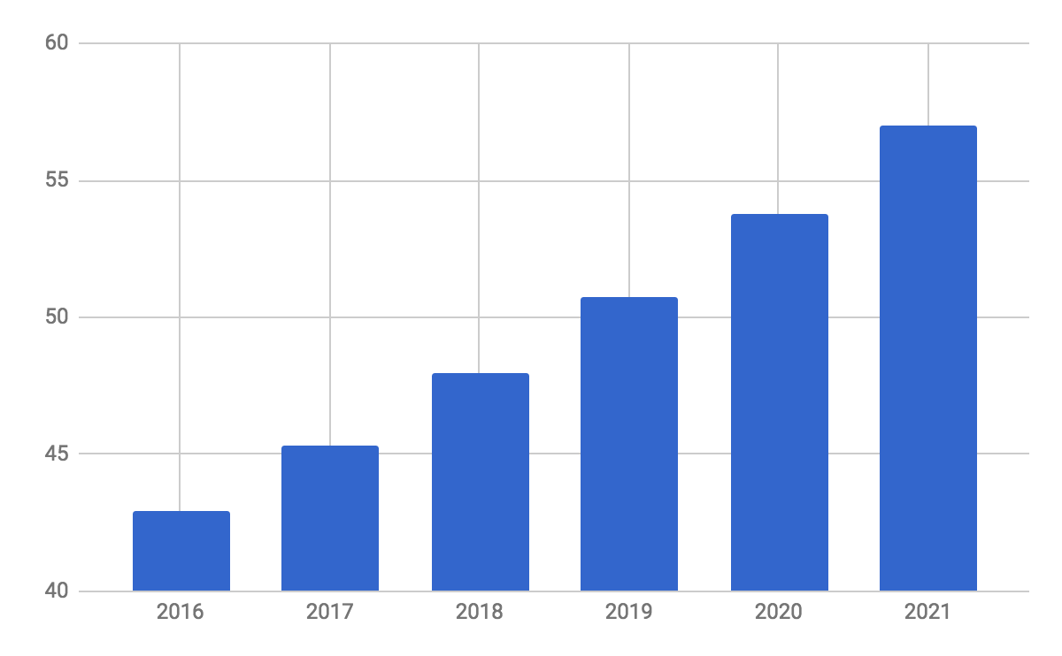

Corporate wellness market projected growth, 2016-2021 (Technavio, 2017)

#### **2. Size of industry and market segment**

In the United States, IBISWorld puts the size of the corporate wellness industry at (2017):

|  |  |
| --- | --- |
| **Revenue** | **$6.4 Billion** |
| **Profit** | $933.9 Million |
| **Annual Growth (2011 – 2016)** | 0.7% |
| **Annual Growth (2016 – 2021)** | 3.3% |
| **Businesses** | 951 |

Internationally, the Technavio put that number at $45.34 billion (2017), despite only 9% of the more than 3 billion global workers being provided access to workplace wellness programs at their jobs (Global Wellness Institute, 2016).

40% of this market revenue is generated by large private sector businesses, our market segment of concern (Turk, 2016).

#### **3. Market Segment Trends**

**Increased Government Support:**

* As the health concern of the global population has been increasing, governments around the world have been supporting corporate wellness programs. For example, the US Affordable Care Act (ACA) penalizes employers that do not provide health insurance to their employees.
* Governments are also trying to push for legislation streamlining the implementation of wellness programs in the workplace. The US Congress is trying to introduce a bill to drive down health costs and improve employee health. Additionally, employers can decrease health insurance premiums for employees that follow healthy behavior.

**Increased Use of Technology:**

* In 2015, 32% of consumers said they had at least one health app on their phone, compared to 16% in 2013 (PwC, 2015, Dec).
* Both industry leaders and employers who adopt the corporate wellness programs are using technology for its convenience, cost and easy accessibility. This also explains the surge of software applications that promote well-being and fitness programs.
* Companies are using applications and websites to promote well-being for the employees and for the general population, contributing to the growth of the corporate wellness market.

**Growth in number of company initiatives:**

* Companies started introducing initiatives for employee well-being to increase their productivity. For example, General Electric offers free preventive screenings, a 24/7 health hotline, and the Expert Medical Opinion program to its employees. This resulted in decrease in sick leave and lower rates of turnover. While leading companies are introducing these initiatives, other businesses are learning that employee wellness has a direct correlation with their productivity.

#### **4. Major Factors Affecting Market Growth**

**Longer working hours and increased human lifespan:**

* As the lifespan of the global population is increasing, more older people working past their retirement age. These people require extra assistance in their daily work life, and require extra care from a business’s perspective.

**Growing awareness about stress:**

* As more people realize the impact of stress to productivity, companies are taking initiatives to reduce stress. For example, Volkswagen’s email amnesty limits access to work devices after core business hours for most of its staff. This also gives an advantage to companies like Wisdom Works and Virgin Pulse that try to gather information about employees that require a change in unhealthy behavior to affect positively to the productivity.

#### **5. Competitive Environment**

##### **ComPsych:** Largest private company in providing employee assistance programs **Market share:** 7.4% (Turk, 2016)

**Revenue (2016):** $475.4 million

**Segment coverage:** services covering health risk assessments, tobacco cessation programs, weight management programs, and lifestyle coaching programs (Technavio, 2017)

**Marketing competence:** provides services to 29,000 companies and more than 78 million employees in 130 countries (Technavio, 2017)

##### **Beacon Health Options Inc. (subsidiary of FHC Health Systems):**

##### Independent behavioral health and wellness company

**Market share:** 5.0% (Turk, 2016)

**Revenue (2016):** $198.966 million (Hoovers, 2017)

**Segment coverage:** options and coverage for employees, having expertise in workplace health and performance

**Marketing competence:** provides services to 41 Fortune 500 companies and other businesses, serving over 50 million people in both the United States and the United Kingdom (Beacon, 2017)

##### **OptumHealth Inc.**

##### Private company offering varying healthcare solutions (including health insurance options) for other businesses, including corporate wellness programs

**Revenue (2016):** $4.0 billion (Patrick, 2016)

**Segment coverage:** offers care solutions, which include care management program that offers case management, disease management, decision support, and wellness programs

**Marketing competence:** serves 34 million people with the behavioral health services

#### **6. New Entrants**

By integrating data and analysis into their software, many new entrants seek to personalize the wellness programs of large corporations.

**Peerfit**

· Digital platform that’s helping insurance carriers, brokers and employers redefine corporate wellness programs

· Serves more than 30,000 people in more than 30 cities (Dorbian, 2017)

· Raised $4.36 million USD over seven rounds from nine investors (CBInsights, 2017a)

**YouEarnedIt**

· Private leading HR software-as-a-service platform aimed at improving employee experience through integrating wellness incentives with other employee engagement activities, allowing employees to earn prizes

· Raised $8.0 million USD over two rounds from six investors (CBInsights, 2017b)

· Estimated revenue: $5.9 million (The Business Journals, 2017)

#### **7. Key Technologies**

Much of the players in the wellness industry recognize the competitive advantage yielded by quick adoption of technology. Current key technologies that has drawn the most attention:

##### **Mobile Health:**

Mobile health rose out of the mobile revolution a few years ago. It comprises primarily of mobile consumer devices, connected medical devices and related mobile technology. mHealth products take advantage of the mobility of its platform to provide services to users regardless of location or situation. The flexibility and convenience does come at the cost of overgeneralized solutions per user. Compared to a dedicated assistant or consultant, the mHealth solution will lack in specificity and personalization.

*Example products:*

**Fitbit** - An internet-of-things wearable that seeks to encourage and track personal physical fitness.

**Epocrates** - Medical information reference app targeted at medical practitioners. Seeks to provide up-to-date information whenever needed.

##### **Telehealth:**

Focuses on providing counselling or therapeutic services digitally, typically through voice or video chat - sometimes leverages remote medical devices. Typical point of view is that this places the power back into the patient’s hands. This technology sacrifices a personal interaction for convenience and typically price reduction

*Example products:*

**Aviza** - end-to-end telehealth solution aimed at providing a solid platform for everything a practitioner or patient might require. Supports connected peripherals as well as collaboration tools for multiple practitioners.

**Talkspace** - Provides dedicated digital therapists for on-demand therapy at a monthly subscription cost. Claims to focus on anxiety, depression, stress, PTSD, and various disorders.

##### **Big Data Solutions:**

The importance of data within the healthcare industry has been on a constant rise. The combination of high availability of data with high demand for better insights into uncertainty has bred an environment in thirst for better data driven solutions. Though for a product to succeed, it must have access to some existing data source.

*Example products:*

**AstraZeneca** - partnered with HealthCore (Wellpoint subsidiary) to determine most economic and effective treatments for chronic illnesses and ailments.

**HealthConnect** - ensures secure and robust data exchange across medical facilities as well as promote usage of electronic health records. Claims to have made significant improvements in cardiovascular disease treatment.

#### **8. References**

Beacon Health Options. (2017). Who We Are. Retrieved from <https://www.beaconhealthoptions.com/who-we-are/>

CBInsights. (2017). Peerfit Profile. Retrieved from CBInsights database

CBInsights. (2017). YouEarnedIt Profile. Retrieved from CBInsights database

Dorbian, I. (2017, June 13). Employee health benefits platform Peerfit garners $2.3 mln. *The PE Hub Network*. Retrieved from https://www.pehub.com/2017/06/employee-health-benefits-platform-peerfit-garners-2-3-mln/#

Global Wellness Institute. (2016). Statistics and Facts. Retrieved from <https://www.globalwellnessinstitute.org/press-room/statistics-and-facts/>

Hoovers. (2017). Beacons Health Options, Inc. Competition. Retrieved from <http://www.hoovers.com/company-information/cs/competition.beacon_health_options_inc.1f12ceb4d7cf4e17.html>

Patrick, M. (2016, April 22). Behind OptumHealth’s and OptumInsight’s Strong Revenue Growth in 1Q16. *Market Realist*. Retrieved from http://marketrealist.com/2016/04/optumhealth-optuminsight-reported-strong-revenue-growth-1q16/

PwC Health Research Institute. (2015). Top health industry issues of 2016: Thriving in the new health economy. Retrieved from https://www.pwc.com/us/en/health-industries /top-health -industry-issues/assets/2016-us-hri-top-issues.pdf

Technavio. (2017). Global Corporate Wellness Market. Retrieved from Factiva database.

The Business Journals. (2017). YouEarnedIt. Retrieved from http://companies.bizjournals.com/profile/youearnedit/153460/

Turk, S. (2016, July). Corporate Wellness Services in the US. Retrieved from IBSWorld database.